Parent Signature ______________________________ (Assigned on Mon. 12/3 - Due on Wed. 12/19)
Student Name _________________________________Project Choice:______________________
Social Studies Constructive Models of the Middle Ages in Europe Project
Language Arts Research and Writing Assessment
400 Assessment/Project points for both LA and SS

Language Arts Research and Writing Assessment  Requirements: 100 points each  - Research is evident and sources are cited  - Information is accurate, relevant, and formatted in a cohesive manner  - Presentation of findings  - Effort and time  Total: ______/400 Points | Social Studies Middle Ages in Europe Project  Requirements: 100 points each  - Met all requirements of individual model (as outlined below)  - Model depicts an accurate display of info.  - Presentation of findings  - Creativity, effort and time  Total: ______/400 Points

Directions: Below is a list of various models you can make to demonstrate your knowledge and expertise within one of the characteristics/structures of a civilization. Choose one model that sounds interesting to you and go ahead and make it! Be sure to follow all the guidelines and directions for your model. Be ready to PRESENT your project and writing to your classmates, parents, and staff members on December 20th! Visit
www.miss-stacy-bush.weebly.com for research suggestions.

In Class Work Days:  Friday 12/7 (Research and Writing  Wednesday 12/12 (Writing)  Friday 12/14 (Building Day 1)  Tuesday 12/18 (Building Day 2) | Pacing Due Dates for Project:  Wednesday 12/5- Project Choice due  Friday 12/7- Research due  Wednesday 12/12- Writing portion due  Wednesday 12/19- Model/Project due

--------------------------------------------------------------------------------------------------------------------------------------
Geography:
Physical Features: Construct a model of the geographic region of Europe and the Mediterranean during the Middle Ages with physical features such as rivers, mountains, and forests clearly differentiated. Provide a written composition describing the geographic features, how it affected the area, and present-day countries.
Requirements: If model is placed on a poster board, the board may NOT BE SMALLER THAN 11X17. Make sure you cite sources used.

Deforestation: Research current situations of deforestation in the USA and create a slideshow, iMovie, or Clips to showcase the situation and explain the effects of doing so- both positive and negative.
Requirements: Must cite sources used when researching and for any pictures or video footage used. Include your opinion on deforestation and support your claim with logical reasoning and relevant evidence.

Religion:
Illuminated Manuscript: Create an illuminated manuscript describing a clergy person from Medieval Europe, and write a biography describing the life of this person and how he or she contributed to society.
Requirements: Must be on a poster at least 11x17. Writing must be in ink or typed. Make sure to cite sources used for your research for the biography.

Cathedral: Construct a 3D model of a cathedral and attach an explanation of the architectural features used, the history of cathedrals in Medieval Europe, and any other interesting facts about the cathedral.
Requirements: Use any creative materials. Make sure to cite sources used when researching information about cathedrals for writing portion. You may use videos as a source.

Stained Glass: Create a stained glass scene that illustrates something from the Roman Catholic Bible. Provide a written description on the scene you created, and the history of iconoclasm in Medieval Europe.
Requirements: Use creative materials. Must cite sources used when researching iconoclasm and the Bible.

Achievements/Culture:
Transportation: Construct a 3D model of a Viking ship that would have been used when the Vikings invaded coastal towns in Medieval Europe. Include a written explanation of the history, how it was made, and what beneficial elements it entailed.
Requirements: Must cite sources used when researching. Must showcase accurate portrayal of a Viking ship.

Art: Create a mosaic of a person who interests you from Medieval Europe and write a biography describing the life of this person and how he or she contributed to society. Some people to consider: Charlemagne, Joan of Arc, William the Conqueror, Thomas Aquinas, King Richard I, King John, Otto I, Robin Hood
Requirements: Must be on a poster at least 11x17. Writing must be in ink or typed. Make sure to cite sources used for your research for the biography.

Politics/Government:
Justinian’s Code: Write at least 3 of Justinian’s Code in Latin or Greek and on a separate sheet of paper respond to the prompt: Compare/contrast Justinian’s Code to American laws today. Are our laws fair or too harsh? How are they similar or dissimilar to Justinian’s Code?
Requirements: Must be on a poster at least 11x17. Writing must be in ink or typed. Make sure to INCLUDE evidence (this means you will have to research!)

War Strategies: Research then showcase at least 3 Medieval European war strategies and tactics AND include armory and other military weaponry. Must provide a summary explaining each picture –each picture should represent the war tactics, armory and other military weaponry.
Requirements: If you choose to showcase on a poster board, the board may NOT BE SMALLER THAN 20X28. Make sure to cite your sources. Technology option: Use iMovie, Clips, or Keynote as model.

Magna Carta and the U.S. Bill of Rights: Write a multi-paragraph essay where you compare and contrast the Magna Carta and the U.S. Bill of Rights. Identify 3 similarities and 3 differences.
Requirements: Cite sources, and include why these documents are important to society. Technology option: Use Clips or iMovie to create a news report including the information above.

Economy:
Trade: Construct a map that showcases Medieval Europe’s trade partners. Include 5 imports and 2 exports in visual representation with captions. Provide a written explanation of the partners, imports, and exports used.
Requirements: Map must be on an 11X17 size poster OR LARGER!

Watermill: Construct a 3D model of a water mill that would have been used in Medieval Europe. Describe the history and evolution of the water mill in writing.
Requirements: Use creative materials. Cite sources used for researching the water mill.

Social Levels:
Feudal Estate: Build a 3D model of a feudal estate. Provide a written composition describing the layout, history, and components of a feudal estate. Where did the nobles live? Knights? Peasants or serfs? What did the houses look like? Were they different for high, middle, and low class? What were their homes made out of? What did they look like? What all was included on the feudal estate? Why were they built?
Requirements: Make sure to use functional materials that represent the houses and overall feudal estates.

You must complete a Works Cited Page
This is a list of the sources you used to gather your information.
It must follow the format below:
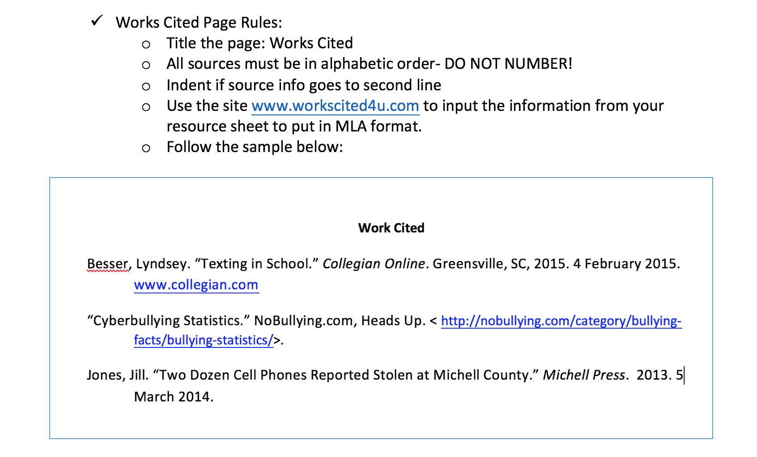

AUTHOR-
LAST NAME, FIRST NAME

